
IT342-Section
SYSTEMS INTEGRATION AND ARCHITECTURE 1

FUNCTIONAL REQUIREMENTS SPECIFICATION (FRS)

Project Title: User Registration & Authentication
Prepared By: Gave C. Hontiveros
Date of Submission: January 30, 2026
Version: 1

Table of Contents
1. Introduction 3
1.1. Purpose 3
1.2. Scope 3
1.3. Definitions, Acronyms, and Abbreviations 3
2. Overall Description 3
2.1. System Perspective 3
2.2. User Classes and Characteristics 3
2.3. Operating Environment 3
2.4. Assumptions and Dependencies 3
3. System Features and Functional Requirements 3
3.1. Feature 1: 3
3.2. Feature 2: 3
4. Non-Functional Requirements 3
5. System Models (Diagrams) 4
5.1. ERD 4
5.2. Use Case Diagram 4
5.3. Activity Diagram 5
5.4. Class Diagram 6
5.5. Sequence Diagram 7
6. Appendices 7

Introduction

Purpose
- User Registration & Authentication is a system that allows user to Register, Log in, and logout of the System

Scope
The system will allow users to Register, Log in, and logout and that’s about what the system can do.

Definitions, Acronyms, and Abbreviations
Registration - the action or process of registering or of being registered.
Authenticaton - the process or action of proving or showing something to be true, genuine, or valid.
User - a person who uses or operates something, especially a computer or other machine.

Overall Description

System Perspective
Describe how the system fits into a larger context or environment.

User Classes and Characteristics
Identify the different types of users and their characteristics.

Operating Environment
Specify the hardware, software, and tools required to operate the system.

Assumptions and Dependencies
List any assumptions and external dependencies that may affect the system.

System Features and Functional Requirements
Describe each major feature of the system and its functional requirements.

Feature 1:
Description:
Functional Requirements:
-
-
-

Feature 2:
Description:
Functional Requirements:
-
-
-

Non-Functional Requirements
Specify system quality attributes such as performance, security, usability, reliability, etc.

System Models (Diagrams)
Insert the necessary diagrams for the system:

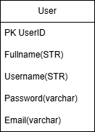
ERD

Use Case Diagram
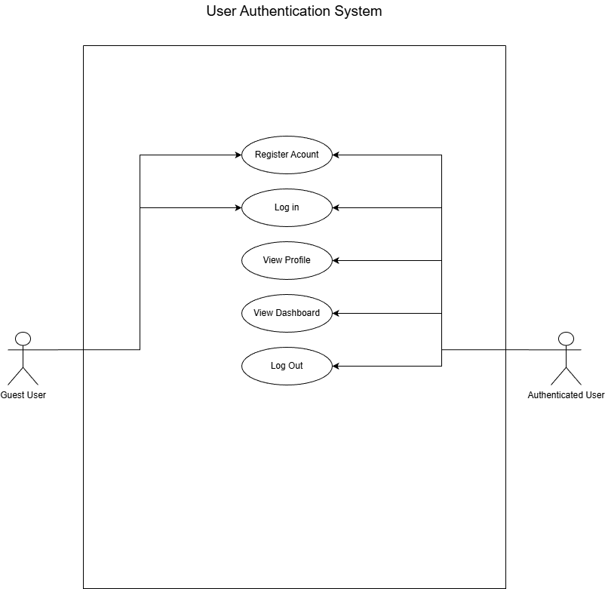

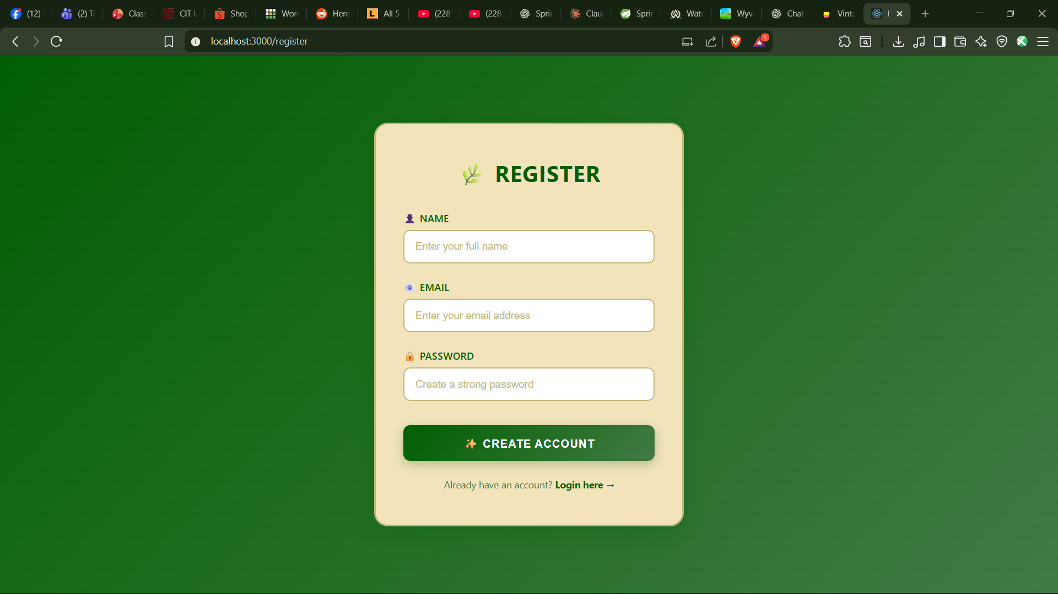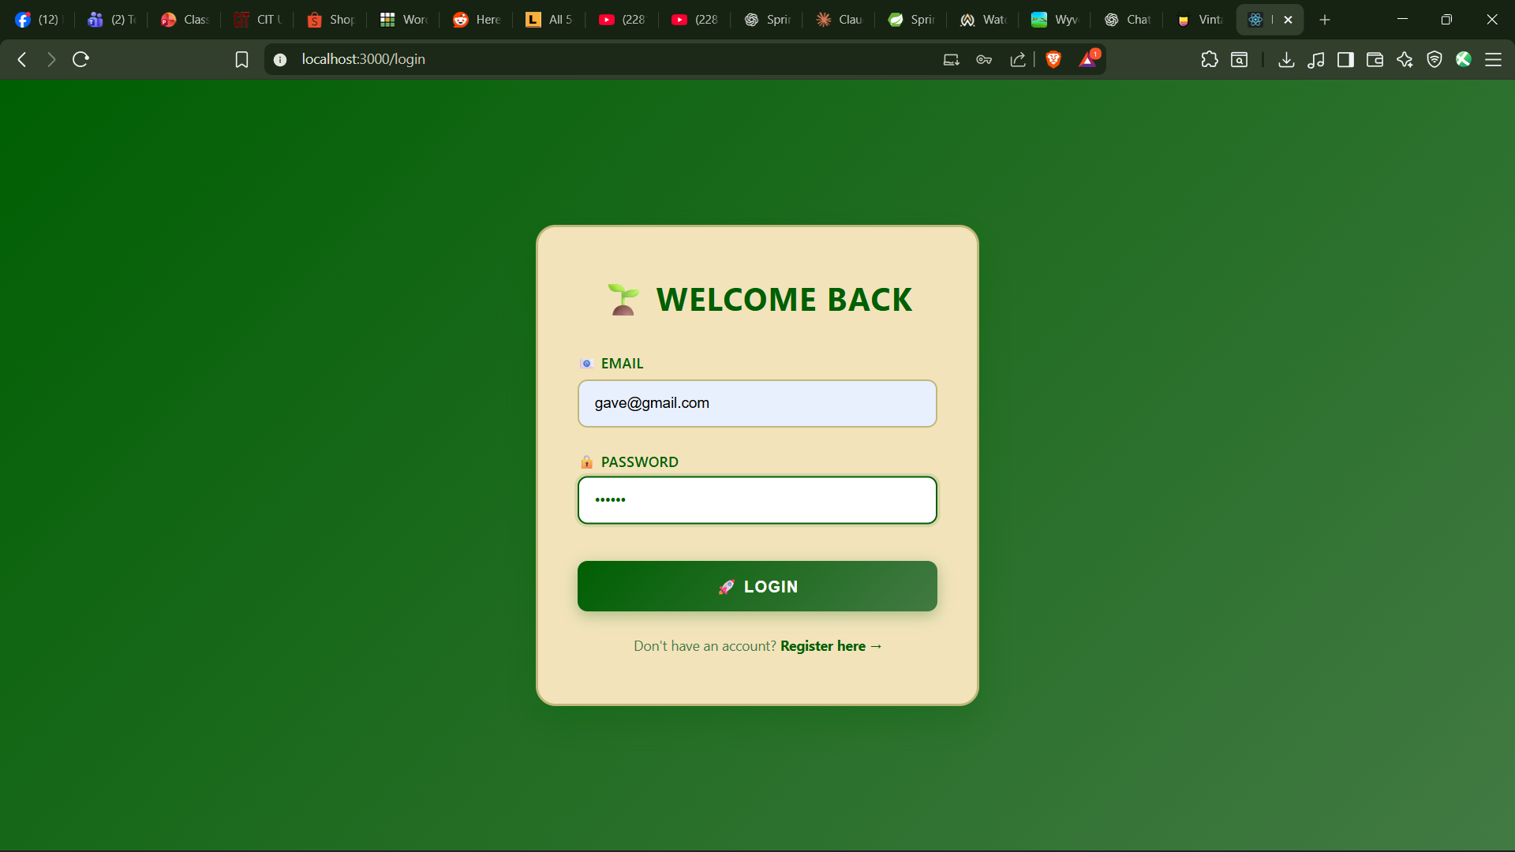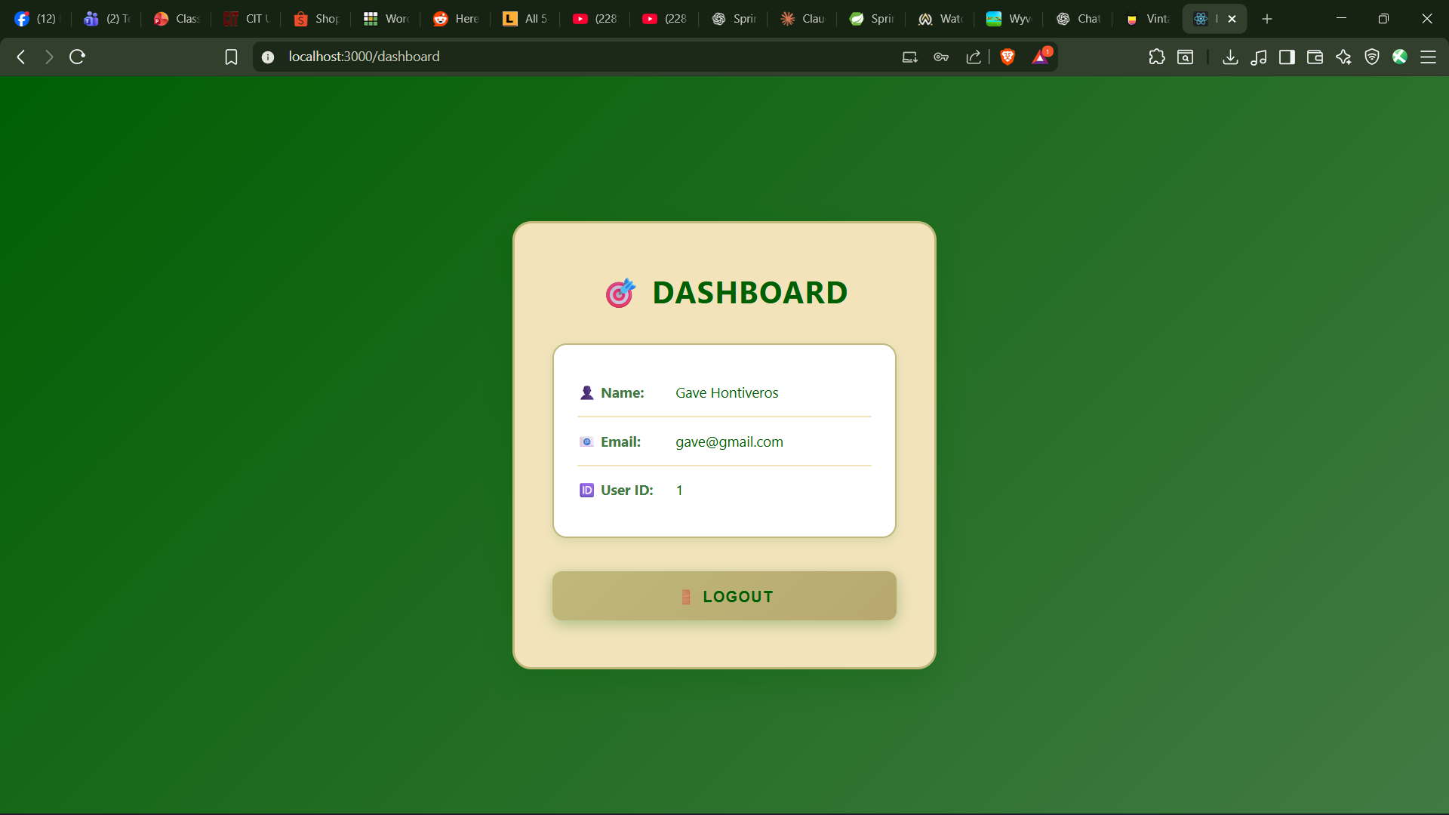

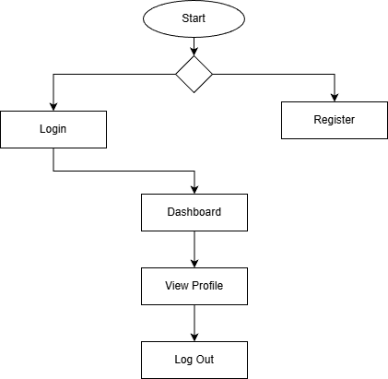
Activity Diagram

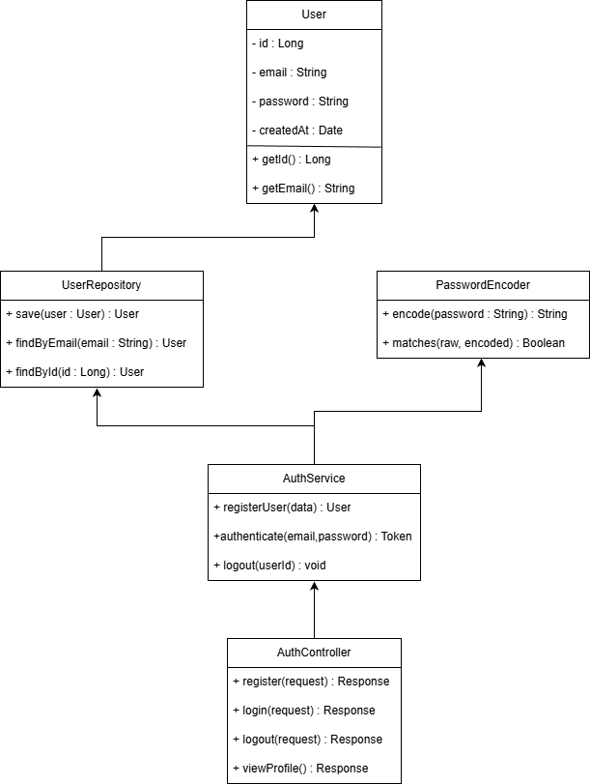
Class Diagram

Sequence Diagram
Insert ERD here

Appendices
Include any additional information, references, or support materials.

